Supporting Lahaina Fire Survivors - Donation Request

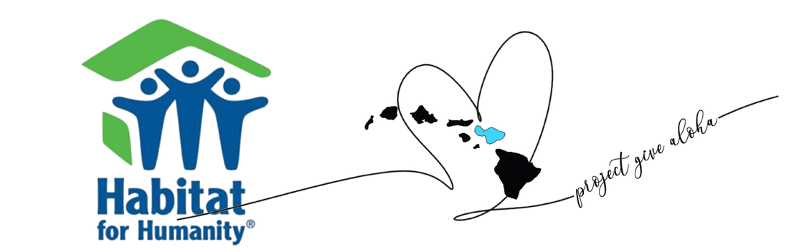

Aloha,
My name is and I am reaching out to ask for your support as I prepare to travel to Maui to serve as a volunteer helping families affected by the devastating Lahaina fire.
I have committed to lock arms with Project Give Aloha, an organization deeply connected to the community and personally impacted by the August 8, 2023 fire. Through their partnership with Habitat for Humanity Maui, I have been given the meaningful opportunity to help rebuild a home in Lahaina that was destroyed in the fire. I am truly honored to be part of this effort.
Project Give Aloha and Habitat for Humanity Maui are collaborating to provide newly built, safe, and affordable housing for fire survivors. This upcoming trip will be the fourth Project Give Aloha volunteer event, and the work is only just beginning. While much of the world has moved on, many Lahaina families are still displaced, struggling, and waiting for help.
To participate in this volunteer trip, I am fundraising for the associated costs:
- Flight: $
- Housing, transportation, food, and logistics: $
The total amount I need to raise is $ , and I am humbly asking for your support. Any amount—large or small—will help make it possible for me to be on the ground, serving directly where the need is greatest.
In addition, any extra funds raised beyond my travel expenses will be placed directly into the hands of Hawaiian families who are still in urgent need. Project Give Aloha will personally honor families on the island with donations collected during this trip.

Thank you so much for taking the time to read this and for considering supporting this mission. The people of Lahaina still need us—now more than ever.
With gratitude,
[Your Name]

In Addition: If you have any interest in joining us for the volunteer trip you can check it out right here at www.projectgivealoha.com

To Sponsor or Donate you can send it to me via Venmo Your account here

Thanks so much for your support…as we lift up the Lahaina survivors and give aloha know that your donation is very appreciated and will go towards good for the islanders!

